Jianhe 120M Musical Water Fountain With Beam Lights and 3D Laser Hologram Projection for Water Column Screen

Project Description:
The music fountain in Kaili jian river county, floating type 120 meters length,24 meters width ,uses 100meters high spray, laser and 8500 Lumen projectors, high speed digital moving head lights, water column screen(which is the patent of AUS RAINBOW), with the work with engineering and Mr. Thomas,it was played with successful performance October 10!

In order to celebrate the 10th Anniversary Opening Celebration for China Jianhe Yang A Sha Cultural Festival and the Relocation of the county on Oct 11th, 2016, Jianhe county government cooperated with AUS RAINBOW Group to creat the Yang A Sha water screen movie fountain lighting show. Total 4 parts, 1st is musical dancing water fountain show, 2nd is lighting show, 3rd is water screen movie show, 4th is digital water curtain.
Project Site：Kaili, Jianhe county, Guizhou Province
Project Cost: RMB40, 000,000
Project Period: October 2017
Project Stage: Accomplished
Project Content: Design, Production, Onsite Installation &Debugging

Project Reference Photos:

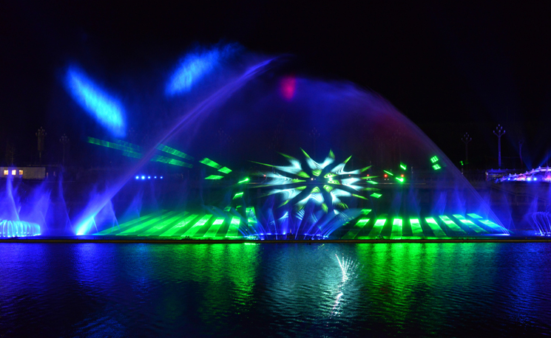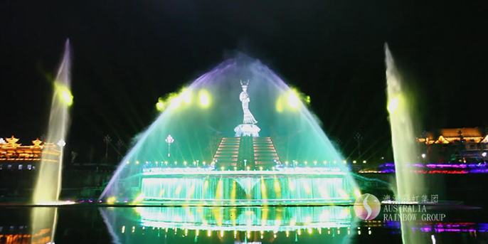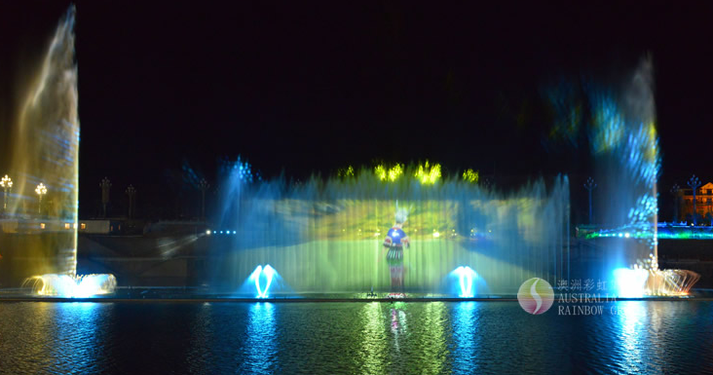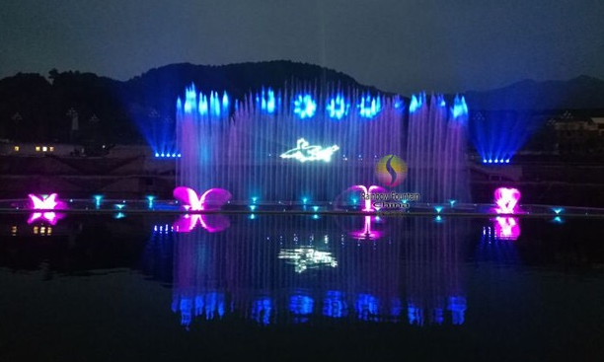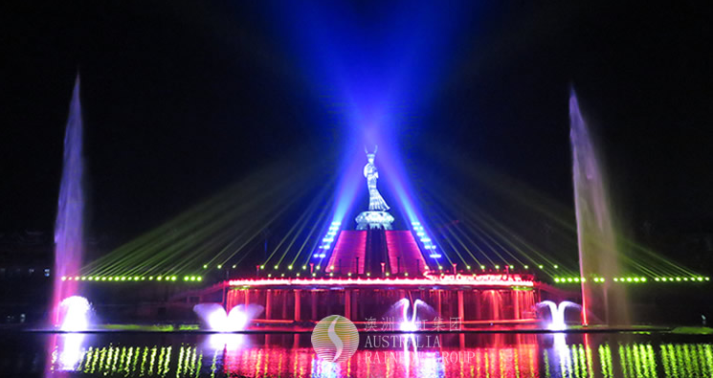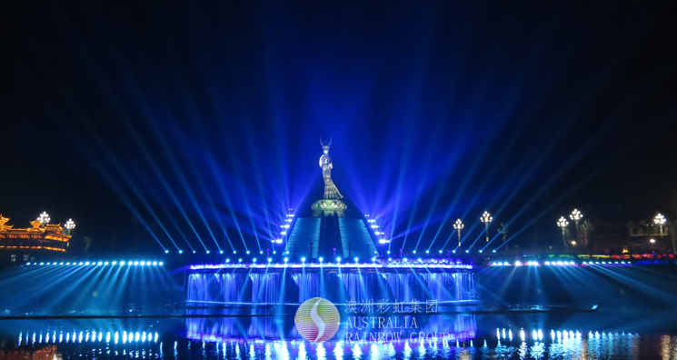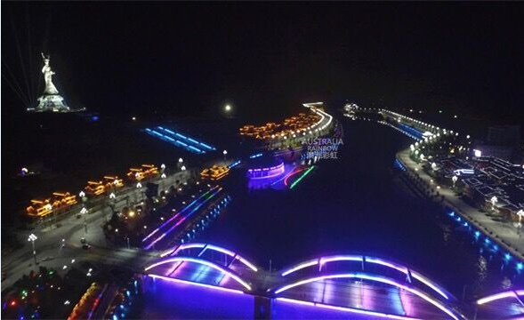
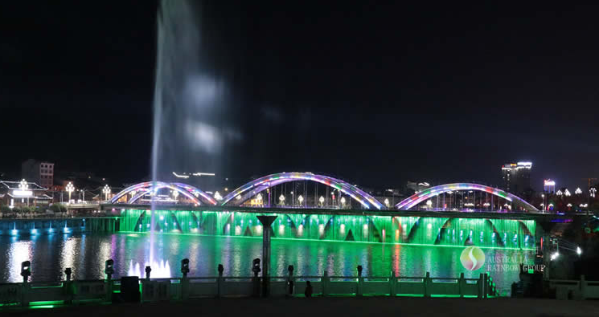

Site Situation
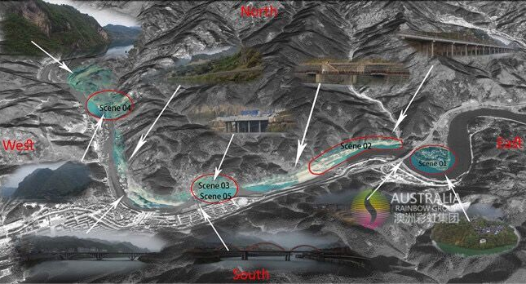
Design Consult Mr. Thomas on site to know about local culture for water screen movie fil
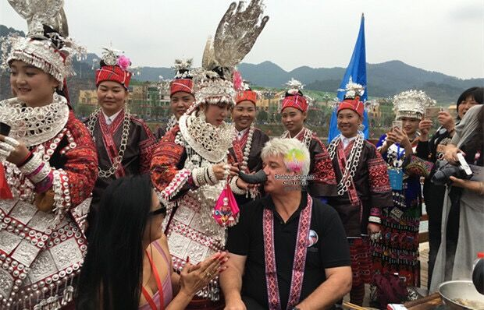

Site Installation and Commissioning
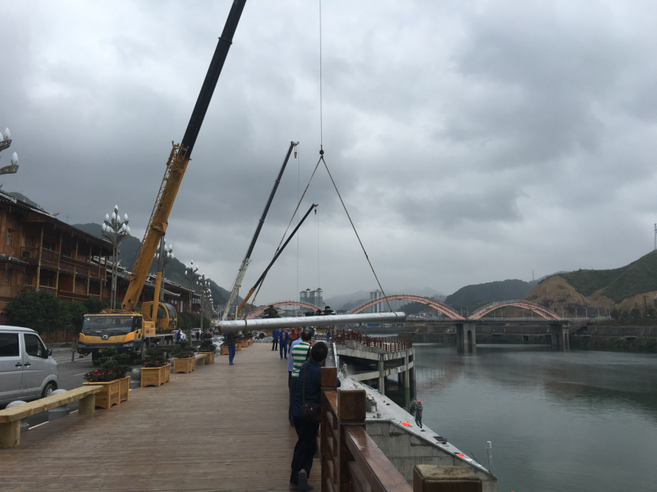

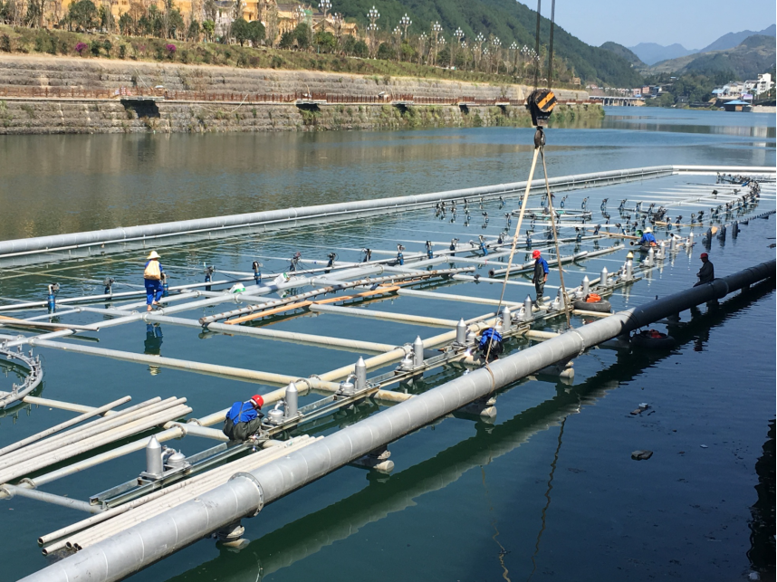
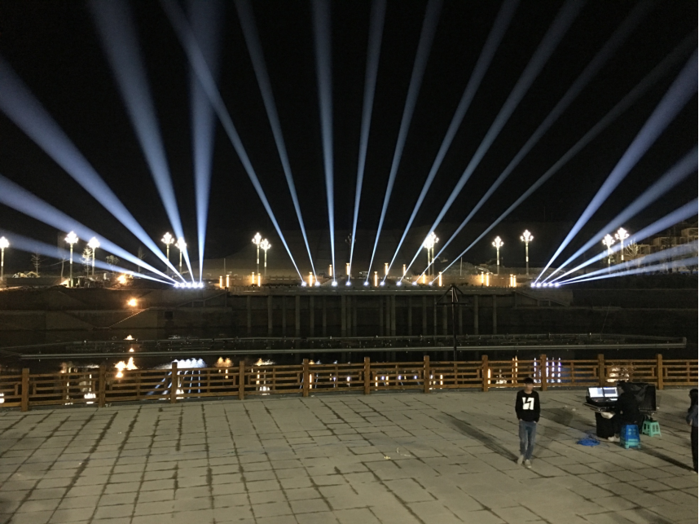
Master Designer MR. Andy and engineer team on site programming
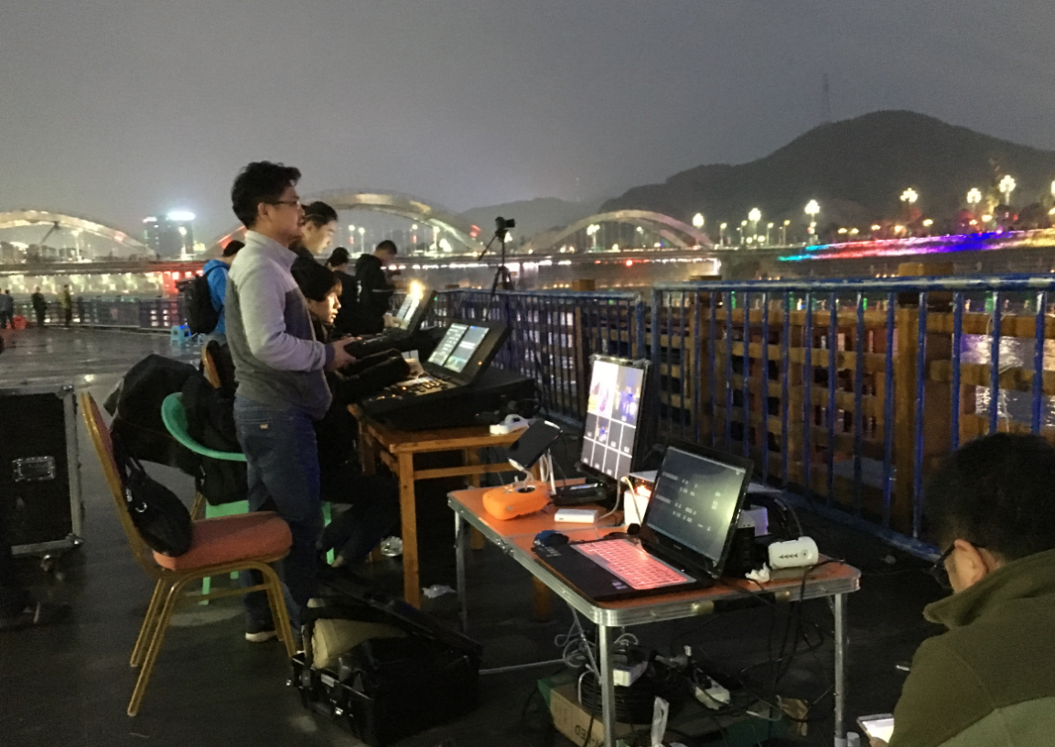

Bridge digital water curtain installation on site
